SUMMER 2016 PACKET FOR AP ENGLISH LANGUAGE AND COMPOSITION
Mrs. Dawn Lewis—Room 313
dlewis@kahoks.org (school)
dw11161@aol.com (home)
https://thelewislair.weebly.com (my website)

The primary purpose of this class is to prepare students to take the AP English Language and Composition Exam in May 2017. If your test score is high enough, you may be eligible to receive college credit for an English class (usually 3 credit hours for the basic English composition course) with no charge for tuition. This class (AP English Language and Composition) consists of college level material with an emphasis on writing. Nonfiction on a wide variety of topics will be the primary reading focus.
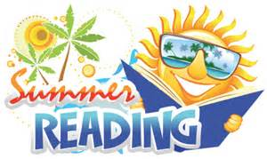
Two books are required for summer reading. You need not purchase a new copy. Used copies are fine (Amazon and Alibris are sites I recommend for used copies) as are electronic copies (Kindle or Nook). Borrowing the books from a friend or a library is also acceptable; however, assignments will be made throughout the year from the Thank You for Arguing book.
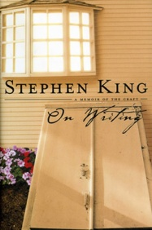 Your first assigned reading is On Writing by Stephen King (yes, that Stephen King). Your edition may look different. Mine does. On Writing is, as the title suggests, about writing. Specifically, it is about his life, his work, and his advice to other writers. Trust me. Most students think they will hate the book, but end up liking it. This book is a look at the process of writing from one of the most prolific and successful American authors alive. One of the things we will focus on this year is why and how writers write, and how this information can help us to become better writers. I think you will find that this book is not as dry and boring as you believe it will be.
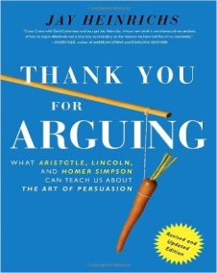 Your second assigned reading is Thank You for Arguing by Jay Heinrichs. This is probably the best, easiest text about argumentation that I have found. Like the King book, this has some humor and wit to it. The subject matter is serious, but the author’s tone is not. We will refer to this text often throughout the year.
Summer reading is necessary as it will give us all the same starting point to work from. We will be referring to both books frequently throughout the year. If you are not familiar with the work and the ideas presented, you will be lost from the very beginning. Blogging comments on the reading will also be required. Instructions for this are posted on my website. I will be transitioning to a new website when the new school year begins, but this one will be in operation until then. If, for some reason, you cannot post a comment for a particular section of (or the entire) book, you may do a double entry (dialectical) journal instead. This would include being gone on vacation, at camp, or family emergency, etc. A combination of blogging and dialectical journal is acceptable. Instructions and an example of a dialectical journal entry are on my website listed above. I expect at least ten entries per chapter or section. Dialectical journals must be submitted the first day of classes (August 17th ). You may begin blogging early, but please make sure you are commenting in the right sections.
My website contains the information you will need for this class. Become familiar with this site. You will use it all through the year, and it lists assignments, links, and other information you will need. Go to the home page and you will see links to all of my classes (you may need to go to “More”). Follow the directions on the site to join the blog. Please do not wait until the last minute, since it may take a few days to establish your blog account.
Purchase Texts—BOTH PURCHASE TEXTS ARE REQUIRED. BOTH HAVE ASSIGNMENTS AS PART OF THE SUMMER PACKET—DO NOT WAIT AND END UP ON BACK ORDER!!!
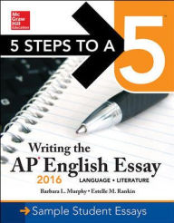 5 Steps to a 5—Writing the AP English Essay 2016—This workbook provides useful information and exercises to build skills necessary to do well on both the AP English Language and Composition Exam and the AP English Literature and Composition Exam. Please make sure that you get the correct title (there are other books for the same exam, but we will be using this one in class) and the correct year’s edition (2016). The book retails for $18.95, but you may be able to find it cheaper on the Amazon or Barnes and Noble websites. I do not recommend buying a used copy since this is a workbook, and the exercises may have been completed by the previous owner. We will be using most of the workbook this year as we develop our skills for the exam. PLEASE COMPLETE THE FIRST THREE CHAPTERS IN THIS BOOK BEFORE SCHOOL STARTS.

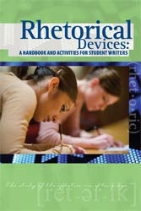 Rhetorical Devices--This is a handbook that not only gives the meaning of different rhetorical devices, but allows students to practice finding them in real writing from writers varying from Shakespeare to John F. Kennedy, similar to what they will have to do on the AP exam. It also gives students practice in creating their own examples of various rhetorical devices. This book may be obtained from the publisher, Prestwick House, www.prestwickhouse.com or call 1-800-932-4593. Rhetorical Devices costs $14.95. Shipping is usually extra. PLEASE READ AND COMPLETE PAGES 3-16 BY AUGUST 17. DO NOT COMPLETE EXERCISE 2 (Understatement) ON PAGE 17.

Additional books needed:

By end of October: The Overachievers: The Secret Lives of Driven Kids by Alexandra Robbins
By January: Between the World and Me by Ta-Nehisi Coates

IF, FOR ANY REASON, YOU CANNOT OBTAIN A COPY OF ANY OR ALL OF THE SUMMER READING BOOKS OR CLASS BOOKS FOR ANY REASON, INCLUDING FINANCIAL HARDSHIP, PLEASE CONTACT MRS. LEWIS IMMEDIATELY. YOU NEED NOT GIVE ME A REASON. I WILL MAKE SURE YOU HAVE A BOOK. DO NOT WAIT UNTIL SCHOOL STARTS!

Your summer schedule is as follows:
We will start with On Writing. I do not give page numbers because of the number of different editions of the book. Look for chapters or chapter headings. If I do not answer right away, do not panic. Keep in mind you may respond to what I am asking or to another student’s comment. You may also introduce your own idea. Each book is worth 25 pts. Blogging more than once per section may result in additional (bonus) points.

Section One—Stop at “What Writing Is”
Posting Due June 3
Section Two—Stop at “On Writing”
Posting Due June 10
Section Three—Stop at “On Living: A Postscript”
Posting Due June 17
Section Four—Finish book
Posting Due June 24

Your first blog will not appear immediately after you post it. As a matter of fact, it will not appear until I approve it. Be patient! Also there is no rule against reading ahead; just be sure you are posting comments in the correct place so you don’t give away parts others have not read yet.

For Thank You for Arguing, follow the schedule below:

Introduction July 1

Offense July 15

Defense July 22

Advanced Offense July 29

Advanced Agreement August 5

In addition to the blogging go to Argument Lab in the Appendices and complete the Other Hand Experiment, Other Other Hand Experiment, and the Fool on the Hill Argument.

Reading and Blogging Done! On to the second part of the packet.

Again, more information will be available on the website . You or your parents may contact me through my e-mail address (home address) during the summer or during the school year (school address) should you have questions or concerns. Please read over this paper and look at the website before you contact me with questions. I think you’ll find most of the answers in one of those two places.
Other Summer Assignments
Along with the assignments above from 5 Steps to a 5, Rhetorical Devices, and Thank You for Arguing, the following is to be done before the beginning of the school year and is due the first day of classes (August 17). This work allows me to assess your current skill level and prepares you for what we will be doing from day one.
To begin with, read about Socrates and the allegory of the cave from Plato’s Republic. A simplified version is available at website below.
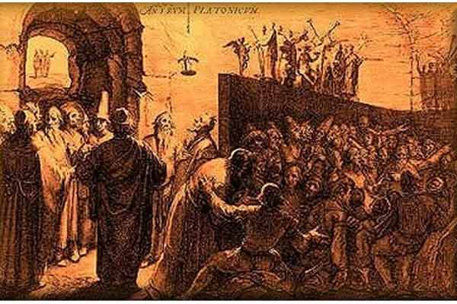
http://webspace.ship.edu/cgboer/platoscave.html
It is a metaphor for the intellectual journey we are undertaking. Please write a paragraph or two that explains 1. what you believe the point of the allegory to be and, 2. how you feel about it. Use standard formal English, MLA format, double-spaced. As an alternative, you may handwrite in blue or black ink. This will serve as a way for me to judge your writing and comprehension skills, so do your best work!

FAILURE TO COMPLETE SUMMER ASSIGNMENT PACKET MAY RESULT IN STUDENT BEING MOVED FROM AP ENGLISH TO ENRICHED ENGLISH III.
FIRST DAY—BRING ASSIGNMENTS TO TURN IN, 5 STEPS TO A 5 WORKBOOK, AND RHETORICAL DEVICE BOOK. SEE YOU THEN!

